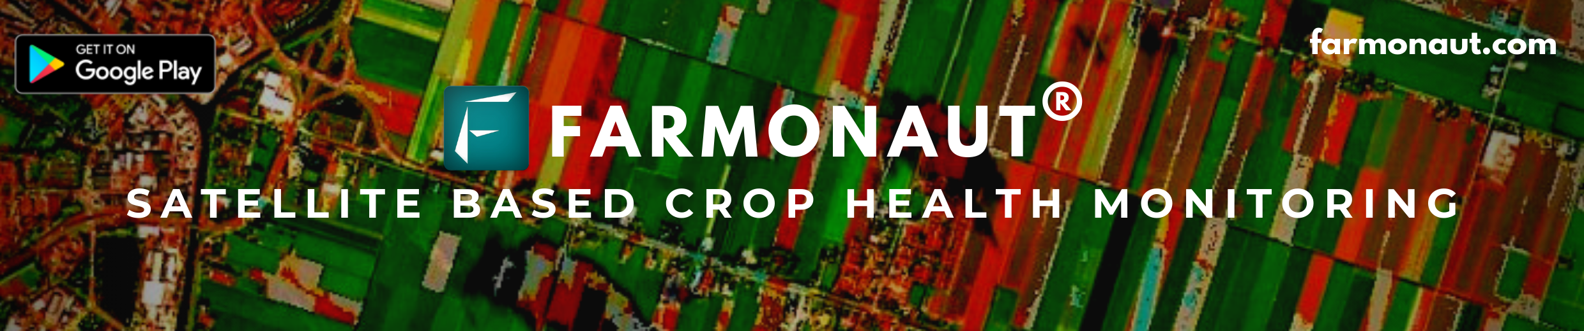

Field Report

This report consists of satellite results of one of your fields. Automated Satellite Monitoring Service allows you to monitor multiple farming fields using latest satellite imagery.

**Note:** *This report is auto-generated by Farmonaut systems. If you have any queries/questions regarding this report then contact us on: support@farmonaut.com*

**Report Generation Date:** *2021-03-26 (in yyyy-mm-dd)*

# Field Details

**Field Address:** *not defined(As Per Google Maps)*

**Field Area:** *70259600 square meters (approx.)*

**Field Location:** *Latitude: 25.231, Longitude: 83.634*

**Satellite Imagery Capture Date:** *2021-03-26 (in yyyy-mm-dd)*

# Weather Statistics on the Imagery Capture Date

**Weather Station:** *Bhabhua*

**Minimum Temperature (°C):** *26.47*

**Maximum Temperature (°C):** *37.19*

**Average Pressure (hPa):** *1009*

**Average Humidity (in %):** *10*

**Average Wind Speed (in m/s):** *2.73*

**Wind Direction (in degrees):** *250*

**Average Cloud Cover (in %):** *0*

# Weather Graphs (Past 5 Days)

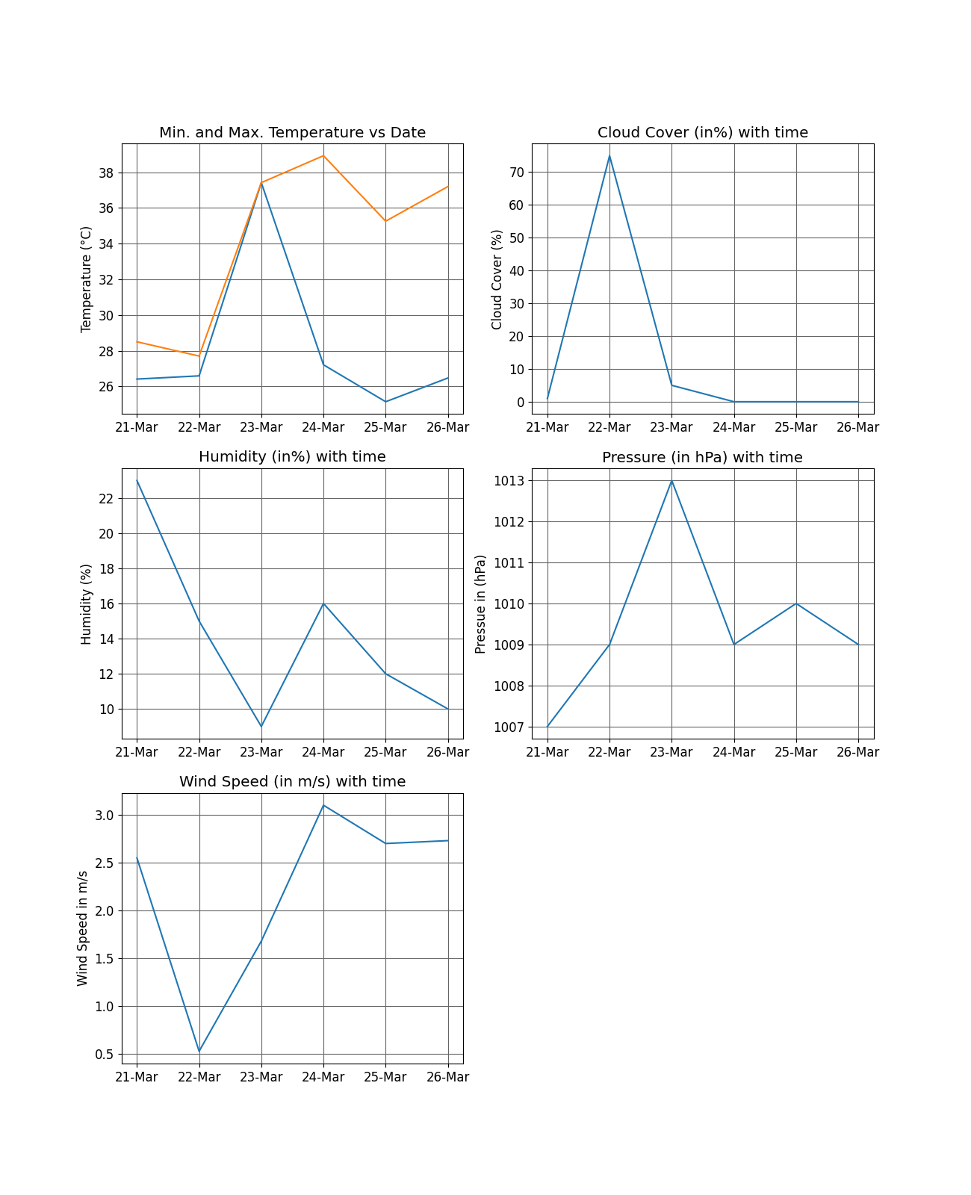

# Weather Forecast (Next 7 Days)

## 2021-03-26

**Clear throughout the day.** *Cloud Cover (in%): 0*

**Min. Temp (°C):** *20.85 at 23:31***, Max. Temp (°C):** *37.38 at 10:39*

**Rain Probability in(%):** *3.0***, Max. Precipitation (in mm. per hour):** *0.0002 at 22:00*

## 2021-03-27

**Clear throughout the day.** *Cloud Cover (in%): 11*

**Min. Temp (°C):** *21.86 at 23:57***, Max. Temp (°C):** *39.41 at 10:37*

**Rain Probability in(%):** *3.0***, Max. Precipitation (in mm. per hour):** *0.0002 at 04:00*

## 2021-03-28

**Clear throughout the day.** *Cloud Cover (in%): 5*

**Min. Temp (°C):** *24.58 at 23:48***, Max. Temp (°C):** *41.96 at 09:12*

**Rain Probability in(%):** *2.0***, Max. Precipitation (in mm. per hour):** *0.0002 at 06:00*

## 2021-03-29

**Clear throughout the day.** *Cloud Cover (in%): 3*

**Min. Temp (°C):** *25.69 at 23:06***, Max. Temp (°C):** *44.79 at 10:47*

**Rain Probability in(%):** *2.0***, Max. Precipitation (in mm. per hour):** *0.0001 at 15:06*

## 2021-03-30

**Clear throughout the day.** *Cloud Cover (in%): 23*

**Min. Temp (°C):** *21.05 at 23:27***, Max. Temp (°C):** *39.36 at 09:40*

**Rain Probability in(%):** *1.0***, Max. Precipitation (in mm. per hour):** *0.0002 at 21:06*

## 2021-03-31

**Clear throughout the day.** *Cloud Cover (in%): 0*

**Min. Temp (°C):** *19.24 at 23:25***, Max. Temp (°C):** *37.7 at 09:55*

**Rain Probability in(%):** *1.0***, Max. Precipitation (in mm. per hour):** *0.0002 at 13:00*

## 2021-04-01

**Clear throughout the day.** *Cloud Cover (in%): 0*

**Min. Temp (°C):** *18.93 at 23:28***, Max. Temp (°C):** *39.03 at 09:47*

**Rain Probability in(%):** *0.0***, Max. Precipitation (in mm. per hour):** *0 at 08:54*

# Index Data for the Satellite Captured Date

|  |  |  |  |  |
| --- | --- | --- | --- | --- |
| NDVI | NDWI | NDRE | VARI | EVI |
| 0.34 | 0.28 | 0.25 | 0.1 | 0.32 |

"Your Crop Needs Attention!"

**The crop is in not growing normally, but is still not in danger zone. Please Open the "My Fields" section on the Farmonaut App and visualize NDVI and NDRE images upon your field and identify the unhealthy areas.**

"Water Stress is in danger zone!"

**The water stress in your field is in bad condition. It means that you need to focus more upon irrigation. A large portion of your field will be affected when less rain or drought condition occurs. Please Open the "My Fields" section on the Farmonaut App and visualize NDWI image upon your field and identify the regions in bad water stress.Basic AnalysisAdvanced AnalysisField in Focus**

Satellite Captured Images

This Single Image Provides information of seven different images (attached in the report below), combined together in a single image. This image is sufficient to take ground level actions. For more in-depth analysis, you can refer to the advance analysis information below.

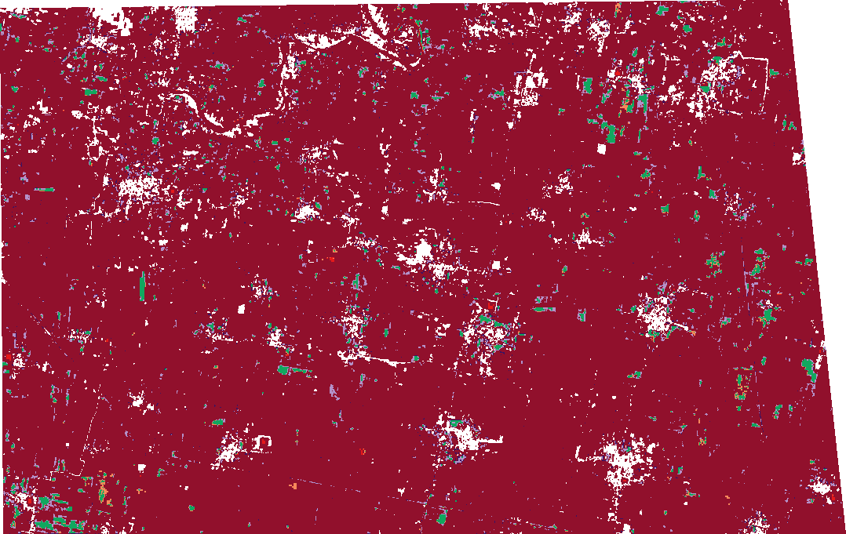

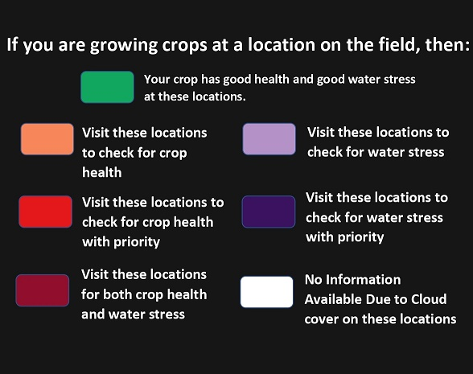

True color image is the unaltered raw satellite image retrieved for your area, whereas Enhanced True Color Image is the Farmonaut processed satellite image of your area with enhanced land features. Using these two images you can see any observable land changes around your field which may be crucial for your farming practices.

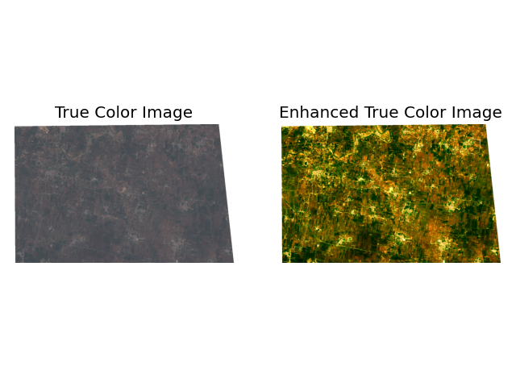

## Normalized Difference Vegetation Index Image (NDVI)

NDVI image provides you a color map of the vegetation of your farming field and nearby areas. The areas shown in red are the regions where the crop growth may not be normal. You should refer to these images when your crop is in the early stage of growth.

**Scientific Background**

NDVI measures status of plant health based on how plants reflect light at certain frequencies. Though we cannot perceive it with our eyes, everything around us (including plants) reflect wavelengths of light in visible and non-visible spectrum. Taking into account how much amount of a certain wavelength is reflected, we can assess the current status of plants. If a plant is healthy, it will have large amount of chlorophyll on its leaves and will absorb good amount of visible light from 0.4 to 0.7 microns and reflect quite less of it and vice-versa. We take into account this basic principle in identifying crop health status of an agricultural land.

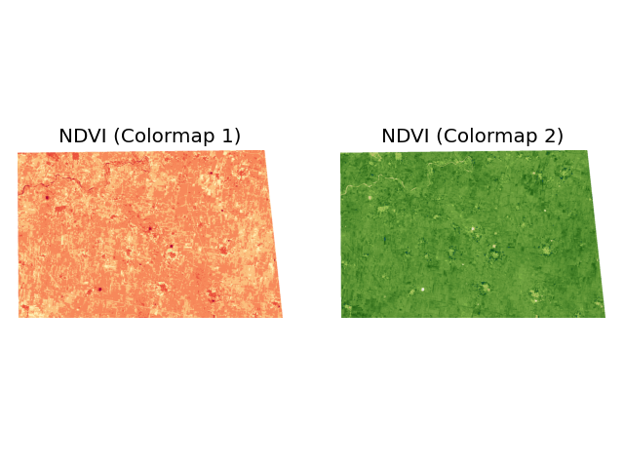

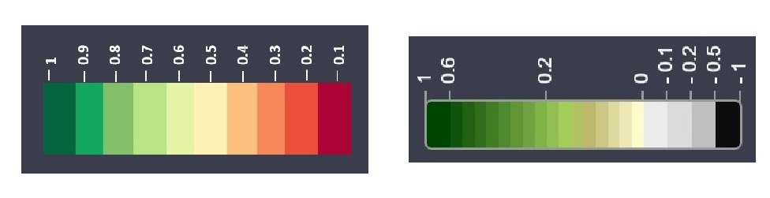

Please check this article to read more about NDVI:  
 https://farmonaut.com/blogs/remote-sensing/normalized-difference-vegetation-index-ndvi/

# Table of NDVI value change with time

|  |  |  |  |  |  |  |  |  |  |  |
| --- | --- | --- | --- | --- | --- | --- | --- | --- | --- | --- |
| Date | 2021-02-04 | 2021-02-09 | 2021-02-14 | 2021-02-19 | 2021-02-24 | 2021-03-01 | 2021-03-06 | 2021-03-11 | 2021-03-16 | 2021-03-26 |
| NDVI Value | 0.5 | 0.48 | 0.55 | 0.51 | 0.63 | 0.62 | 0.62 | 0.51 | 0.44 | 0.34 |

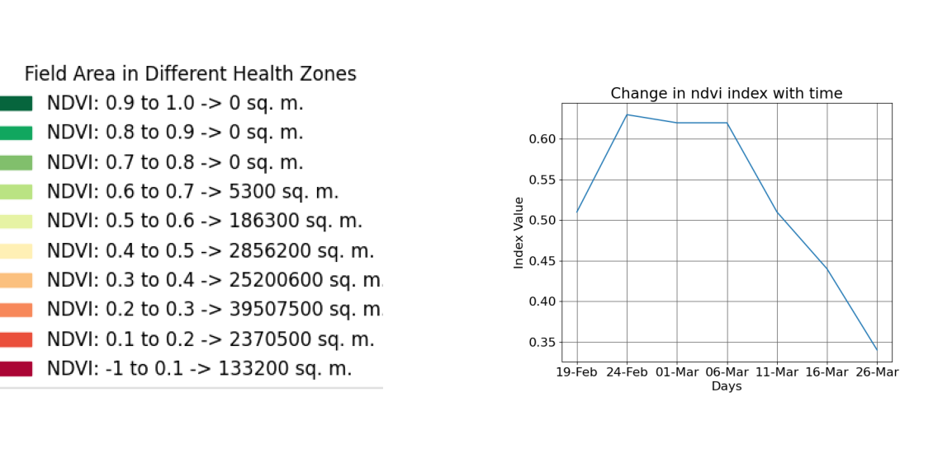

## Enhanced Vegetation Index Image (EVI)

EVI image provides you a color map of the vegetation of your farming field and nearby areas. The areas shown in red are the regions where the crop growth may not be normal. You should refer to these images when your crop is in the later stage of growth and your crop canopy is dense.

**Scientific Background**

The Enhanced Vegetation Index (EVI) uses additional waveelengths of light to correct for the inaccuracies of NDVI. Variations in solar incidence angle, atmospheric conditions like distortions in the reflected light caused by the particles in the air, and signals from the ground cover below the vegetation are corrected for using EVI.

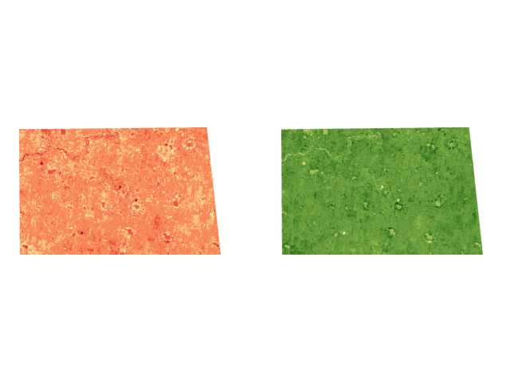



# Table of EVI value change with time

|  |  |  |  |  |  |  |  |  |  |  |
| --- | --- | --- | --- | --- | --- | --- | --- | --- | --- | --- |
| Date | 2021-02-04 | 2021-02-09 | 2021-02-14 | 2021-02-19 | 2021-02-24 | 2021-03-01 | 2021-03-06 | 2021-03-11 | 2021-03-16 | 2021-03-26 |
| EVI Value | 0.48 | 0.47 | 0.55 | 0.52 | 0.63 | 0.64 | 0.64 | 0.49 | 0.42 | 0.32 |

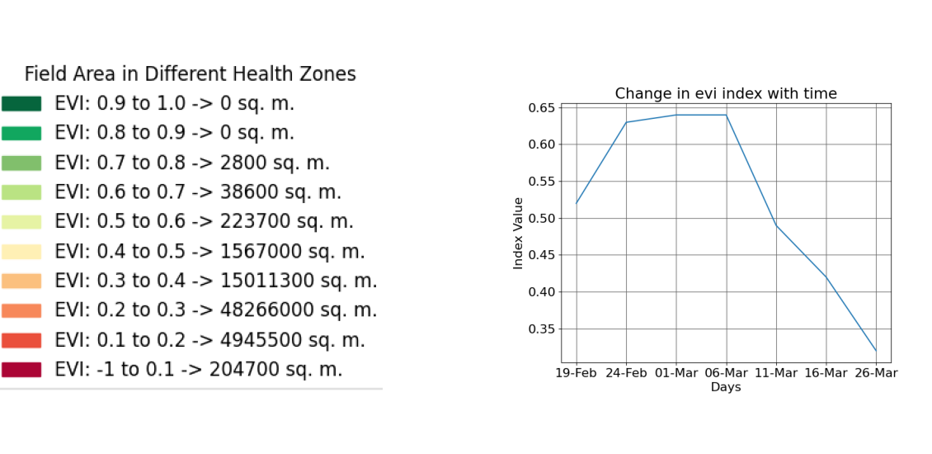

## Normalized Difference Red Edge Image (NDRE)

NDRE image provides you a color map of the vegetation of your farming field and nearby areas. The areas shown in red are the regions where the crop growth may not be normal. You should refer to these images when your crop is in the later stage of growth.

**Scientific Background**

NDRE uses a combination of near-infrared light and a frequency band that is in the transition region between visual red and NIR light. The red edge band of NDRE provides a measurement that is not as strongly absorbed by just the topmost layers of leaves. By using NDRE, one can get better insight into crops in their later stage because it is able to observe further down into the canopy a well. NDRE is also less prone to saturation in the presence of dense vegetation. This will help us get much accurate results in pasture biomass estimation measurements. Thus, in situations like these, NDRE can provide a much accurate and better measurement of variability in an area in which the NDVI measurement would come simply as 1.0

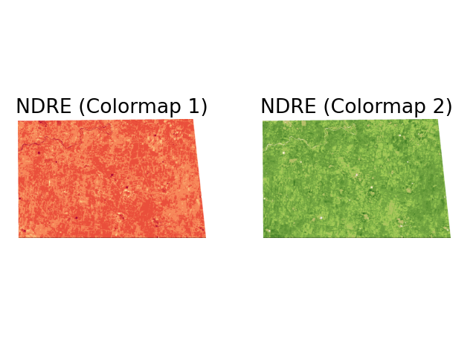



Please check this article to understand the difference between NDVI and NDRE images and their applications in agriculture: https://farmonaut.com/blogs/remote-sensing/ndvi-vs-ndre-and-their-applications-in-agriculture/

# Table of NDRE values with Time

|  |  |  |  |  |  |  |  |  |  |  |
| --- | --- | --- | --- | --- | --- | --- | --- | --- | --- | --- |
| Date | 2021-02-04 | 2021-02-09 | 2021-02-14 | 2021-02-19 | 2021-02-24 | 2021-03-01 | 2021-03-06 | 2021-03-11 | 2021-03-16 | 2021-03-26 |
| NDRE Value | 0.4 | 0.38 | 0.45 | 0.42 | 0.51 | 0.5 | 0.5 | 0.41 | 0.36 | 0.25 |

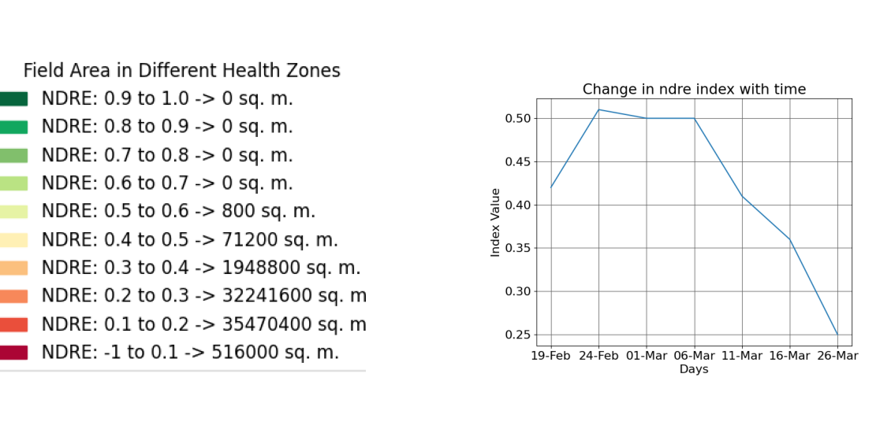

## Normalized Difference Water Index Image (NDWI)

NDWI image provides you a color map of the water level of your farming field and nearby areas. The areas shown in red are the regions where the water level may not be normal. In case of drought or less rainfall, these areas will be the most affected.

**Scientific Background**

Vegetation cover on the earth surface undergoes severe stress during a drought. If affected areas are not identified in time, entire crops may be damaged. Hence, the early detection of water stress can prevent many of the negative impacts on crops. NDWI can help us control irrigation and significantly improve agriculture, especially in areas where meeting the need for water is difficult.

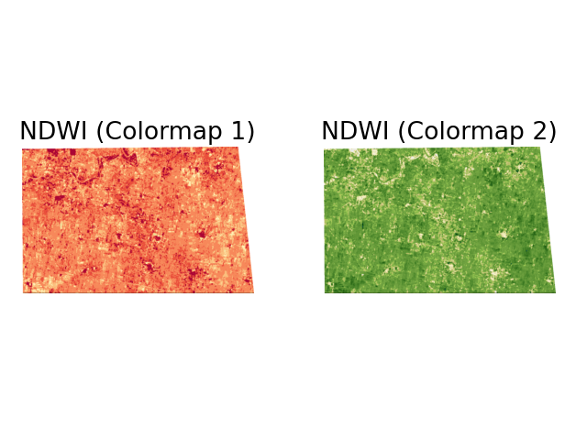



Please check this article to read more about NDWI: https://farmonaut.com/blogs/remote-sensing/normalized-difference-water-index-ndwi/

# Table of NDWI values with time

|  |  |  |  |  |  |  |  |  |  |  |
| --- | --- | --- | --- | --- | --- | --- | --- | --- | --- | --- |
| Date | 2021-02-04 | 2021-02-09 | 2021-02-14 | 2021-02-19 | 2021-02-24 | 2021-03-01 | 2021-03-06 | 2021-03-11 | 2021-03-16 | 2021-03-26 |
| NDWI Value | 0.48 | 0.54 | 0.57 | 0.61 | 0.61 | 0.6 | 0.59 | 0.54 | 0.47 | 0.28 |

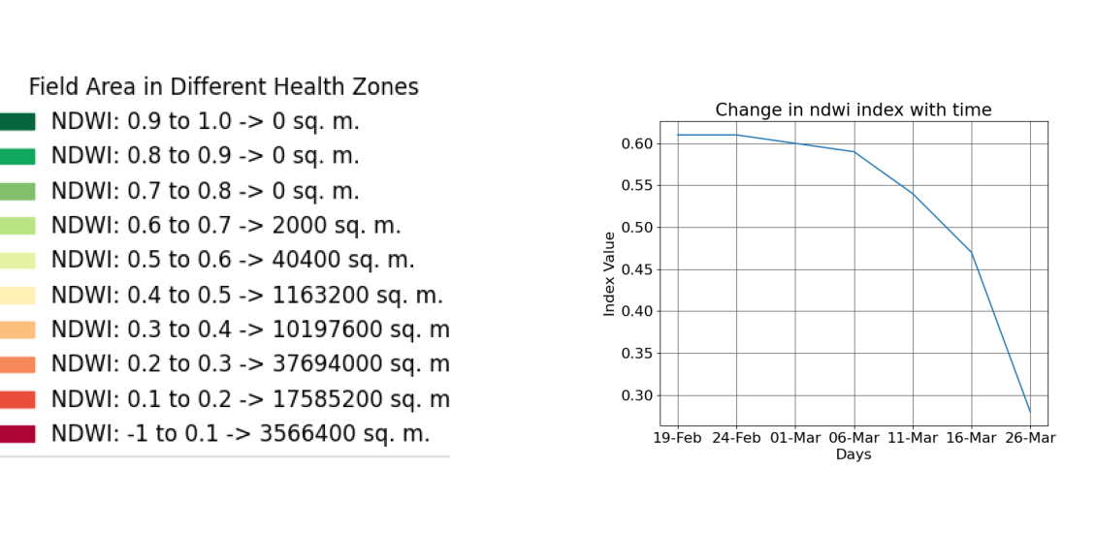

## Evapotranspiration

Satellite remote sensing of evapotranspiration is an essential part of the global observation system and provides inputs for agriculture, water resources management, weather forecasts, climate studies and many other applications.

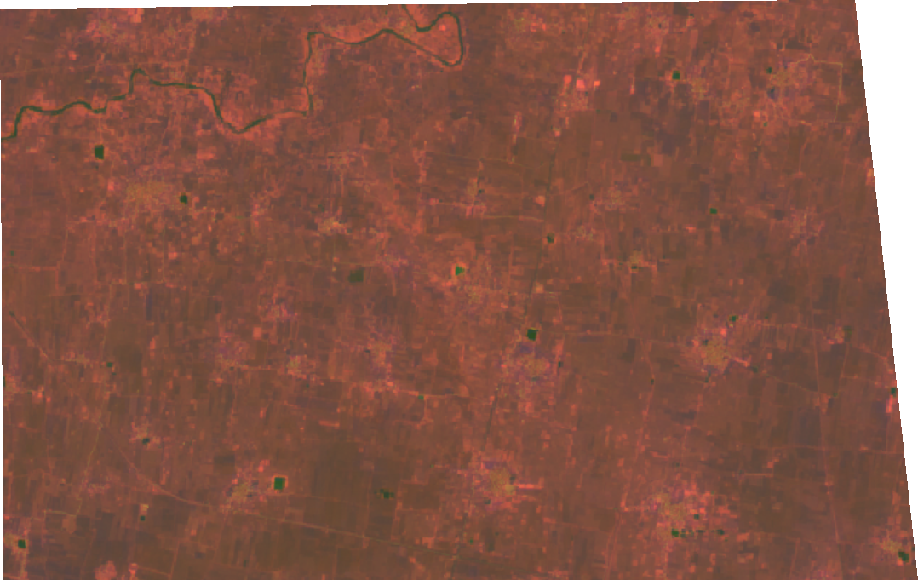

## Soil Organic Carbon Image (SOC)

SOC image provides you a color map of percentage of organic matter present at your selected field. Organic matter contributes to nutrient retention and turnover, soil structure, moisture retention and availability, degradation of pollutants, carbon sequestration and soil resilience. The areas shown in red are the regions where the soil organic carbon is less than 1%.

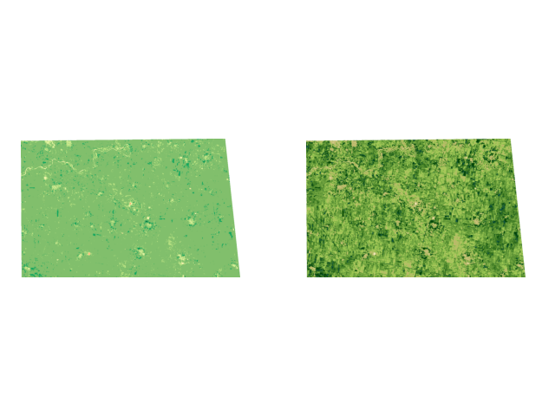

# Table of SOC values with Time

|  |  |  |  |  |  |  |  |  |  |  |
| --- | --- | --- | --- | --- | --- | --- | --- | --- | --- | --- |
| Date | 2021-02-04 | 2021-02-09 | 2021-02-14 | 2021-02-19 | 2021-02-24 | 2021-03-01 | 2021-03-06 | 2021-03-11 | 2021-03-16 | 2021-03-26 |
| SOC Value | 0.24 | 0.23 | 0.26 | 0.24 | 0.28 | 0.28 | 0.28 | 0.24 | 0.22 | 0.2 |

